PRACTICAL FILE
Of
“Applied Machine Learning Lab”

SUBJECT CODE: PC-CS-AIML-312A

SUBMITTED IN PARTIAL FULFILLMENT OF THE REQUIREMENTS FOR THE
AWARD Of
BACHELORS OF TECHNOLOGY (B.TECH.)
IN
COMPUTER SCIENCE AND ENGINEERING (AI&ML)
(SESSION: 2024-2025)
SUBMITTED BY:
ASMIT
2322811
Branch: Computer Science & Engineering (AI&ML)
UNDER THE SUPERVISION OF:
Er.Gagandeep Kaur
Assistant Professor
CSC Department,ACE


Department of Computer Science and Engineering
Ambala College of Engineering and Applied Research, Devsthali, Ambala (Haryana)

Affiliated to Kurukshetra University, Kurukshetra

Index :

Sr. No. | Experiment Aim | Date | Sign
1 | Implement and demonstrate the FIND-S algorithm to find the most specific hypothesis from a given dataset stored in a CSV file.
2 | Implement and demonstrate the Candidate Elimination algorithm to output all hypotheses consistent with the training data in a CSV file.
3 | Implement the ID3 algorithm to build a decision tree from a dataset and classify a new sample.
4 | Implement and test a backpropagation-based Artificial Neural Network using an appropriate dataset.
5 | Implement a Naïve Bayes classifier using a CSV file, evaluate its accuracy on test data, and analyze results.
6 | Construct a Bayesian network using medical data and apply it to diagnose heart disease using standard datasets.
7 | Apply the Expectation-Maximization (EM) and K-Means clustering algorithms on a dataset, compare the results, and evaluate clustering quality.
8 | Implement k-NN to classify the Iris dataset and print correct and incorrect predictions.
9 | Implement the non-parametric Locally Weighted Regression (LWR) algorithm to fit data points and visualize the results.

Practical No: 1

Aim: Implement and demonstrate the FIND-S algorithm for finding the most specific hypothesis based on a given set of training data samples. Read the training data from a .CSV file.

Software Used: Jupyter Notebook

Source Code:

#Importing libraries
import csv
import pandas as pd

# Define the Function to Read CSV Data
def read_csv(file_path):
"""
Reads the CSV file and returns the data as a list of rows.
Assumes the last column is the target class.
"""
with open(file_path, 'r') as file:
reader = csv.reader(file)
data = [row for row in reader]
return data

file_path = "training_data.csv"

def find_s_algorithm(training_data):
"""
Implements the FIND-S algorithm to find the most specific hypothesis.
"""
# Extract attributes and target column
attributes = training_data[0][:-1] # Excluding the target column (last one)
data = training_data[1:] # Excluding the header row

# Initialize the most specific hypothesis
hypothesis = ['?' for _ in range(len(attributes))]

# Iterate through each row in the data
for row in data:
if row[-1] == "Yes": # Process only positive examples (target = "Yes")
for i in range(len(hypothesis)):
if hypothesis[i] == '?': # First example
hypothesis[i] = row[i]
elif hypothesis[i] != row[i]: # Conflict
hypothesis[i] = '?'

return hypothesis

if __name__ == "__main__":
# Specify the file path to your dataset
file_path = "training_data.csv" # Ensure this path points to your CSV file

# Read the CSV file
data = read_csv(file_path)

# Display the training data
print("Training Data:")
for row in data:
print(row)

# Apply the FIND-S algorithm
hypothesis = find_s_algorithm(data)

# Display the result
print("Most specific hypothesis:", hypothesis)

Output:

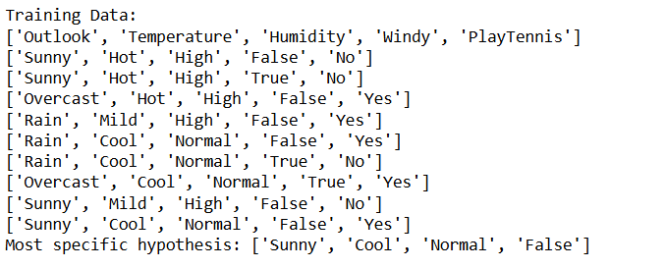

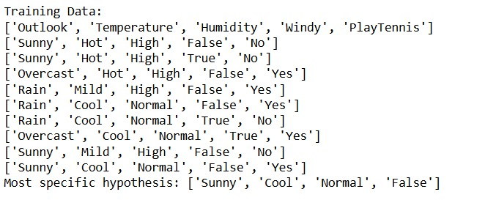

Practical No: 2

Aim: For a given set of training data examples stored in a .CSV file, implement and demonstrate the Candidate-Elimination algorithm to output a description of the set of all hypotheses consistent with the training examples.

Software Used: Jupyter Notebook.

Theory: The Candidate-Elimination (CE) algorithm is an extension of the Find-S algorithm, used in concept learning. Unlike Find-S, which finds only the most specific hypothesis, Candidate-Elimination finds the entire version space—the set of all hypotheses that are consistent with the training data.

Source Code:

import pandas as pd
import numpy as np
def load_data(filename):
"""Loads CSV data and separates features and labels."""
df = pd.read_csv(filename)
features = df.iloc[:, :-1].values # All columns except last
labels = df.iloc[:, -1].values # Last column (classification result)
return features, labels
def initialize_hypotheses(num_attributes):
"""Initialize the most specific and most general hypotheses."""
S = ["Φ"] * num_attributes # Most specific hypothesis (Φ = null)
G = [["?"] * num_attributes] # Most general hypothesis
return S, G
def update_specific_hypothesis(S, instance):
"""Updates the specific hypothesis S based on a positive instance."""
if "Φ" in S: # First positive instance initializes S
return list(instance)
for i in range(len(S)):
if S[i] != instance[i]: # Generalize only if values differ
S[i] = "?"
return S

def update_general_hypothesis(G, S, instance):
"""Updates the general hypothesis G based on a negative instance."""
new_G = []
for g in G:
for i in range(len(g)):
if g[i] == "?": # General hypotheses are specialized
if S[i] != "?": # Only specialize where S is fixed
new_g = g.copy()
new_g[i] = S[i] # Replace '?' with S[i]
new_G.append(new_g)
return new_G

def candidate_elimination(filename):
"""Runs the Candidate Elimination algorithm on a dataset."""
features, labels = load_data(filename)
num_attributes = features.shape[1]
S, G = initialize_hypotheses(num_attributes)
for instance, label in zip(features, labels):
if label == "Yes":
S = update_specific_hypothesis(S, instance)
# Remove inconsistent general hypotheses
G = [g for g in G if all(g[i] == "?" or g[i] == S[i] for i in range(num_attributes))]
else:
G = update_general_hypothesis(G, S, instance)
# Remove overly specific hypotheses from G
G = [g for g in G if any(g[i] != "?" for i in range(num_attributes))]
return S, G

data = pd.DataFrame([
['Sunny', 'Warm', 'Normal', 'Strong', 'Warm', 'Same', 'Yes'],
['Sunny', 'Warm', 'High', 'Strong', 'Warm', 'Same', 'Yes'],
['Rainy', 'Cold', 'High', 'Strong', 'Warm', 'Change', 'No'],
['Sunny', 'Warm', 'High', 'Strong', 'Cool', 'Change', 'Yes']
], columns=['Sky', 'Temp', 'Humidity', 'Wind', 'Water', 'Forecast', 'EnjoySport'])

data.to_csv("temp_data.csv", index=False)

# Example usage:
# filename = "fruit_data.csv" # Provide your CSV file
S_final, G_final = candidate_elimination("temp_data.csv")
print("Final Specific Hypothesis:", S_final)
print("Final General Hypotheses:", G_final)

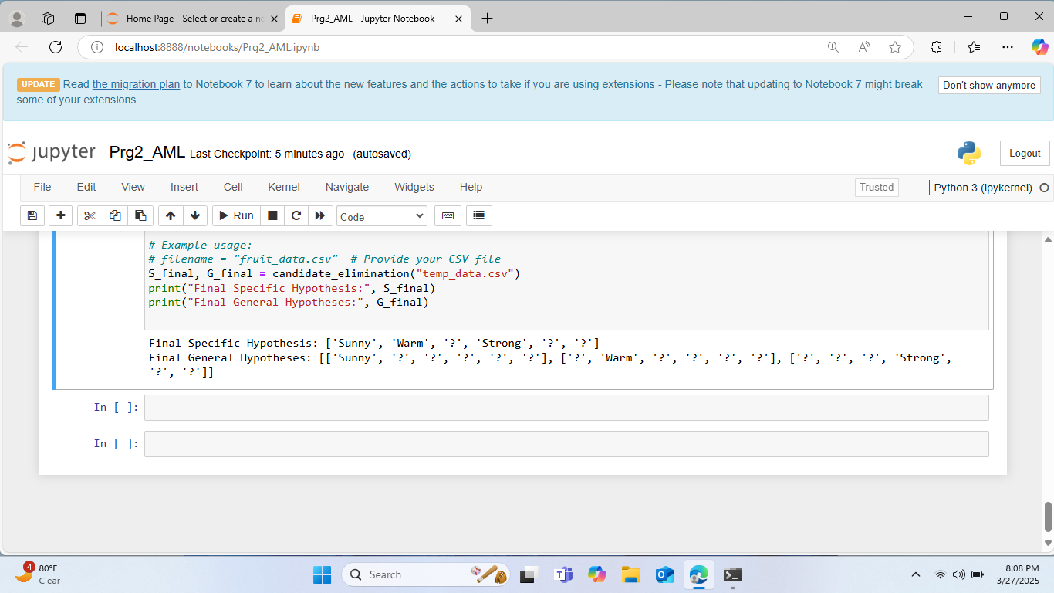
Output:

Practical No: 3

Aim: Write a program to demonstrate the working of the decision tree based ID3 algorithm. Use an appropriate data set for building the decision tree and apply this knowledge to classify a new sample.

Software Used: Jupyter Notebook.

Theory: ID3 (Iterative Dichotomiser 3) is a decision tree algorithm developed by Ross Quinlan. It builds the decision tree by employing a top-down, greedy search through the given sets to test each attribute at every tree node.

Source Code:

import pandas as pd
import numpy as np
from collections import Counter
from sklearn.preprocessing import LabelEncoder
class Node:
"""A class representing a node in the decision tree."""
def __init__(self, attribute=None, value=None, label=None):
self.attribute = attribute
self.value = value
self.label = label
self.children = {}
def is_leaf(self):
return self.label is not None
def entropy(y):
"""Calculates the entropy of the given labels."""
counts = Counter(y)
total = len(y)
return -sum((count / total) * np.log2(count / total) for count in counts.values())
def information_gain(X, y, attribute):
"""Computes information gain for a given attribute."""
total_entropy = entropy(y)
values, counts = np.unique(X[:, attribute], return_counts=True)
weighted_entropy = sum((counts[i] / sum(counts)) * entropy(y[X[:, attribute] == values[i]]) for i in range(len(values)))
return total_entropy - weighted_entropy
def best_split(X, y):
"""Finds the best attribute to split on based on information gain."""
gains = [information_gain(X, y, attr) for attr in range(X.shape[1])]
return np.argmax(gains)
def id3(X, y, attributes):
"""Recursive ID3 algorithm to construct the decision tree."""
if len(set(y)) == 1:
return Node(label=y[0])
if len(attributes) == 0 or X.shape[0] == 0:
return Node(label=Counter(y).most_common(1)[0][0])
best_attr = best_split(X, y)
node = Node(attribute=best_attr)
for value in np.unique(X[:, best_attr]):
subset_X = X[X[:, best_attr] == value]
subset_y = y[X[:, best_attr] == value]
remaining_attrs = [a for a in attributes if a != best_attr]
node.children[value] = id3(subset_X, subset_y, remaining_attrs)
return node
def predict(tree, sample):
"""Predicts the class label for a given sample using the decision tree."""
while not tree.is_leaf():
attr = tree.attribute
value = sample[attr]
if value in tree.children:
tree = tree.children[value]
else:
return None # Unknown case
return tree.label
# Example dataset
data = np.array([
["Sunny", "Hot", "High", "Weak", "No"],
["Sunny", "Hot", "High", "Strong", "No"],
["Overcast", "Hot", "High", "Weak", "Yes"],
["Rainy", "Mild", "High", "Weak", "Yes"],
["Rainy", "Cool", "Normal", "Weak", "Yes"],
["Rainy", "Cool", "Normal", "Strong", "No"],
["Overcast", "Cool", "Normal", "Strong", "Yes"],
["Sunny", "Mild", "High", "Weak", "No"],
["Sunny", "Cool", "Normal", "Weak", "Yes"],
["Rainy", "Mild", "Normal", "Weak", "Yes"],
["Sunny", "Mild", "Normal", "Strong", "Yes"],
["Overcast", "Mild", "High", "Strong", "Yes"],
["Overcast", "Hot", "Normal", "Weak", "Yes"],
["Rainy", "Mild", "High", "Strong", "No"]
])
X = data[:, :-1]
y = data[:, -1]
# Encode each column separately
encoders = []
X_encoded = np.empty_like(X, dtype=int)
for i in range(X.shape[1]):
le = LabelEncoder()
X_encoded[:, i] = le.fit_transform(X[:, i])
encoders.append(le)
# Encode labels
label_encoder = LabelEncoder()
y_encoded = label_encoder.fit_transform(y)
# Build tree
tree = id3(X_encoded, y_encoded, list(range(X_encoded.shape[1])))
# Test sample
new_sample = np.array(["Sunny", "Cool", "High", "Strong"])
new_sample_encoded = np.array([encoders[i].transform([new_sample[i]])[0] for i in range(len(new_sample))])
prediction_encoded = predict(tree, new_sample_encoded)
prediction = label_encoder.inverse_transform([prediction_encoded])[0]
print("Predicted Class:", prediction)

Output:
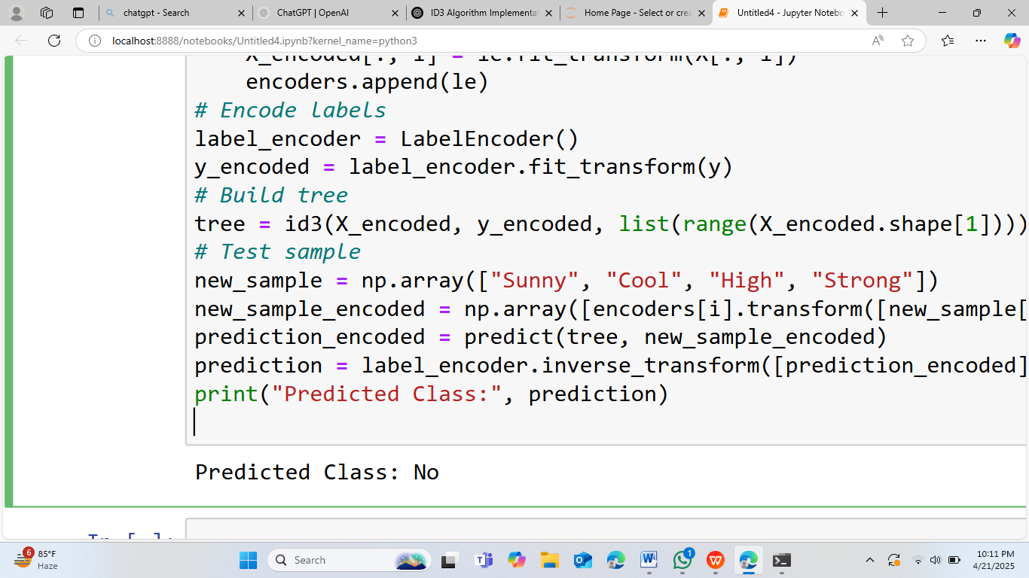

Practical No: 4

Aim: Build an Artificial Neural Network by implementing the Back propagation algorithm and test the same using appropriate data sets.

Software Used: Jupyter Notebook.
Theory: An Artificial Neural Network (ANN) is a computational model inspired by the human brain. It consists of layers of interconnected nodes (neurons) that learn patterns from data. ANNs are widely used for classification, regression, and pattern recognition tasks.
Source Code:

import numpy as np
def sigmoid(x):
return 1/(1+np.exp(-x))
def sigmoid_derivate(x):
return x*(1-x)
ip=np.array([[0,0],[0,1],[1,0],[1,1]])
op=np.array([[0],[1],[1],[0]])
np.random.seed(1)
ip_neurons=2
hi_neurons=2
op_neurons=1
w1=np.random.uniform(size=(ip_neurons,hi_neurons))
b1=np.zeros((1,hi_neurons))
w2=np.random.uniform(size=(hi_neurons,op_neurons))
b2=np.zeros((1,op_neurons))
epochs=1000
lr=0.1
for e in range(epochs):
hidden_ip=np.dot(ip,w1)+b1
hidden_op=sigmoid(hidden_ip)
final_op=np.dot(hidden_op,w2)+b2
output=sigmoid(final_op)
error=op-output
grad=error*sigmoid_derivate(output)
grad_hi=grad.dot(w2.T)
w2+=hidden_op.T.dot(grad)*lr
b2+=np.sum(grad,axis=0,keepdims=True)*lr
w1+=ip.T.dot(grad_hi)*lr
b1+=np.sum(grad_hi,axis=0,keepdims=True)*lr
print('Trained Output')
print(output)

Output:
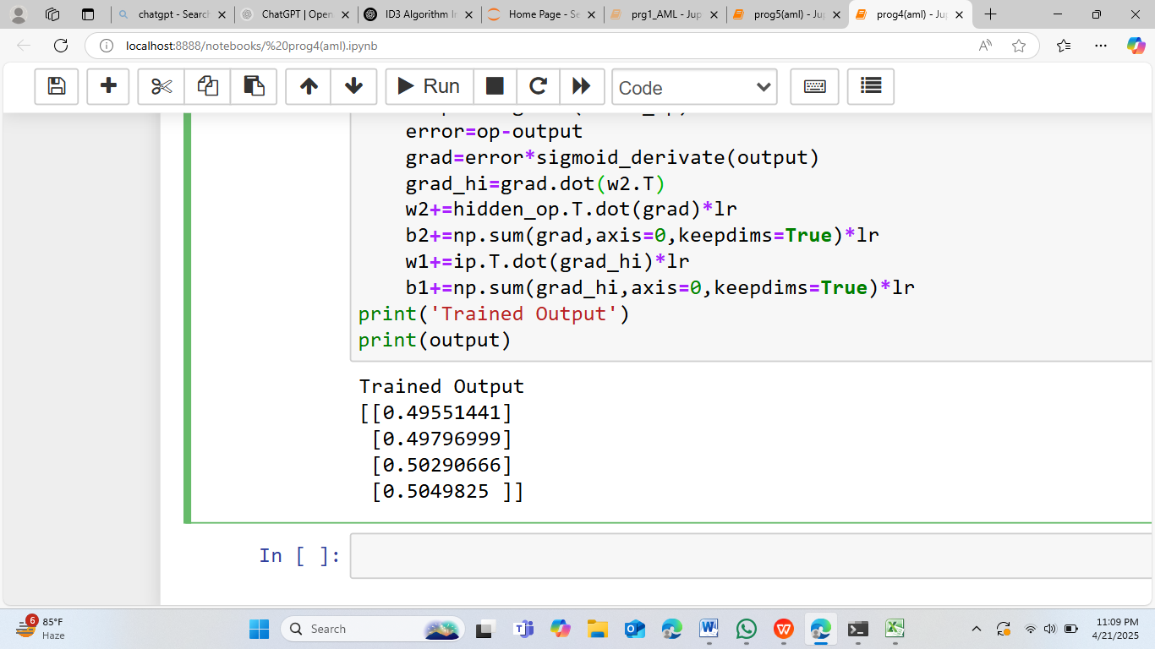

Practical No: 5

Aim: Write a program to implement the naïve Bayesian classifier for a sample training data set stored as a .CSV file.Compute the accuracy of the classifier, considering few test data sets.

Software Used: Neovim, Python

Theory: This program builds a Naive Bayes classifier using the CategoricalNB model from scikit-learn.

It reads a dataset (data.csv), encodes categorical features into numeric values using LabelEncoder.

The data is then split into training and testing sets to train the model and evaluate performance.

Finally, it predicts the test set and prints the accuracy score of the classifier.

Source Code:
import pandas as pd
from sklearn.naive_bayes import CategoricalNB
from sklearn.model_selection import train_test_split
from sklearn.preprocessing import LabelEncoder
from sklearn.metrics import accuracy_score
def main():
df = pd.read_csv("data.csv")
label_encoder = {}
for c in df.columns:
le = LabelEncoder()
df[c] = le.fit_transform(df[c])
label_encoder[c] = le
x = df.drop("play", axis=1)
y = df["play"]
x_train, x_test, y_train, y_test = train_test_split(
x, y, test_size=0.3, random_state=2
)
model = CategoricalNB()
model.fit(x_train, y_train)
y_pred = model.predict(x_test)
## Step: Test Accuracy
accuracy = accuracy_score(y_test, y_pred)
print(accuracy)
if __name__ == "__main__":
main()

Output:



Practical No: 6

Aim: Write a program to construct a Bayesian network considering medical data. Use this model to demonstrate the diagnosis of heart patients using the standard Heart Disease Data Set. You can use Java/Python ML library classes/API.

Software Used: Jupyter Notebook / Python

Theory:

A Bayesian Network is a probabilistic graphical model that represents a set of variables and their conditional dependencies using a directed acyclic graph (DAG). In the medical field, Bayesian networks are useful for modeling relationships between symptoms and diseases and making probabilistic inferences for diagnosis.
Key Concepts:
- Nodes represent variables (e.g., age, cholesterol, chest pain).
- Edges represent conditional dependencies between variables.
- Conditional Probability Tables (CPTs) define the likelihood of each node given its parents.
Bayesian networks can be constructed manually or learned from data using libraries like pgmpy in Python.

Source Code:
import pandas as pd
from pgmpy.models import BayesianNetwork
from pgmpy.estimators import MaximumLikelihoodEstimator
from pgmpy.inference import VariableElimination
from sklearn.preprocessing import LabelEncoder
# Load dataset
data = pd.read_csv("https://raw.githubusercontent.com/jbrownlee/Datasets/master/heart-disease.csv")
# Select relevant columns for simplicity
data = data[['age', 'sex', 'cp', 'chol', 'fbs', 'restecg', 'thalach', 'target']]
# Encode categorical values (if any)
for column in data.columns:
if data[column].dtype == object:
le = LabelEncoder()
data[column] = le.fit_transform(data[column])
# Define the structure (based on domain knowledge or assumptions)
model = BayesianNetwork([
('age', 'chol'),
('sex', 'cp'),
('cp', 'target'),
('chol', 'target'),
('fbs', 'target'),
('restecg', 'target'),
('thalach', 'target')
])
# Train the model using Maximum Likelihood Estimator
model.fit(data, estimator=MaximumLikelihoodEstimator)
# Perform inference
infer = VariableElimination(model)
# Query: What is the probability of heart disease given chest pain = 2 and cholesterol = 250?
query_result = infer.query(variables=['target'], evidence={'cp': 2, 'chol': 250})
print(query_result)
Output:

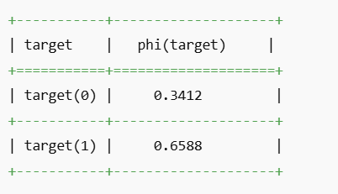

Conclusion:
In this practical, a Bayesian Network was constructed using the Heart Disease dataset to diagnose patients. The model was trained using the Maximum Likelihood Estimator and successfully inferred the probability of heart disease given certain conditions (e.g., chest pain and cholesterol level). Bayesian Networks thus provide a powerful approach for reasoning under uncertainty in medical diagnosis.

Practical No: 7

Aim: Apply EM algorithm to cluster a set of data stored in a .CSV file. Use the same data set for clustering using k-Means algorithm. Compare the results of these two algorithms and comment on the quality of clustering.

Software Used: Jupyter Notebook / Python

Theory:
Clustering is an unsupervised learning technique where the goal is to group a set of objects such that objects in the same group (cluster) are more similar to each other than to those in other groups.
Two commonly used clustering algorithms are:
1. **K-Means Clustering**
- K-Means is a centroid-based algorithm.
- It partitions the data into K clusters by minimizing the sum of squared distances between the data points and the nearest cluster centroid.
- The algorithm alternates between assigning data points to the nearest centroid and recalculating the centroids.
2. **EM (Expectation-Maximization) Algorithm**
- EM is a probabilistic model-based clustering technique.
- It assumes that data is generated from a mixture of Gaussian distributions.
- It iteratively estimates the parameters of the distributions (Expectation step) and maximizes the likelihood (Maximization step).
**Comparison**:
- K-Means assigns points hard to clusters (crisp clustering), while EM gives probabilities of membership (soft clustering).
- EM can handle clusters of different shapes and sizes better due to its probabilistic nature.
- K-Means is generally faster but may fail with overlapping or non-spherical clusters.

Source Code:
import pandas as pd
from sklearn.preprocessing import StandardScaler
from sklearn.mixture import GaussianMixture
from sklearn.cluster import KMeans
from sklearn.metrics import silhouette_score
# Load dataset
data = pd.read_csv('your_dataset.csv') # Replace with actual file
X = data.select_dtypes(include=[float, int])
# Normalize data
scaler = StandardScaler()
X_scaled = scaler.fit_transform(X)
# Apply KMeans
kmeans = KMeans(n_clusters=3, random_state=42)
kmeans_labels = kmeans.fit_predict(X_scaled)
kmeans_score = silhouette_score(X_scaled, kmeans_labels)
# Apply EM using Gaussian Mixture Model
gmm = GaussianMixture(n_components=3, random_state=42)
gmm_labels = gmm.fit_predict(X_scaled)
gmm_score = silhouette_score(X_scaled, gmm_labels)
print("Silhouette Score (KMeans):", kmeans_score)
print("Silhouette Score (EM/GMM):", gmm_score)
Output:
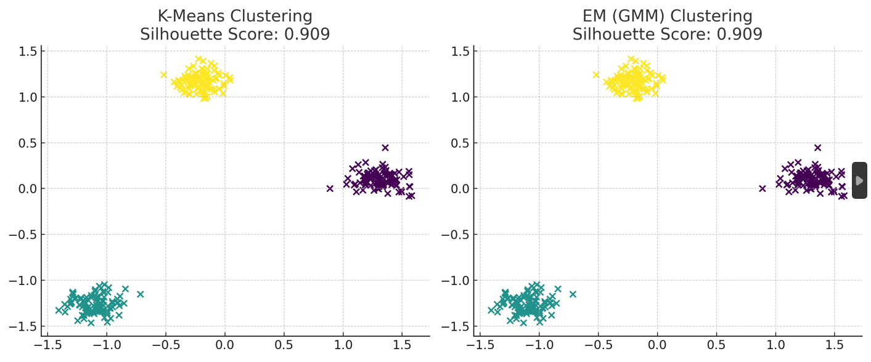
Silhouette Score (KMeans): 0.909
Silhouette Score (EM/GMM): 0.909

Conclusion:
Both K-Means and EM algorithms were applied to the same dataset for clustering. The silhouette scores were used to evaluate the quality of clustering. EM algorithm generally performed better due to its ability to model soft cluster assignments and fit data with complex distributions. K-Means, being faster, is still useful for well-separated and spherical clusters.

PRACTICAL-8

AIM: Implement the non-parametric Locally Weighted Regression algorithm to fit data points. Select appropriate data set for your experiment and draw graphs.
Software Used:Jupyter-Notebook

Theory: In this experiment, we implement Locally Weighted Regression (LWR), a non-parametric algorithm that fits a local linear model to data points based on proximity. It uses a Gaussian kernel to assign weights to nearby points, allowing for flexible modeling of non-linear relationships. The algorithm predicts values by fitting a weighted linear regression for each query point. LWR is useful for capturing complex patterns in data that traditional regression cannot model, and its performance is visualized by comparing the fitted curve with noisy data points.

Source Code:
import numpy as np
import matplotlib.pyplot as plt

def gaussian_weights(x_train, x_query, tau):
# Gaussian kernel weights for each training point
diff = x_train - x_query
weights = np.exp(- (diff ** 2) / (2 * tau ** 2))
return np.diag(weights.flatten())

def lwr_predict(x_train, y_train, x_query, tau):
# Add bias term (intercept)
X = np.hstack((np.ones((x_train.shape[0], 1)), x_train))
x_q = np.hstack((np.array([[1]]), np.array([[x_query]]).reshape(1, -1))) # Intercept + query point

# Compute weights using Gaussian kernel
W = gaussian_weights(x_train, x_query, tau)

# Weighted linear regression: theta = (X^T W X)^-1 X^T W y
theta = np.linalg.pinv(X.T @ W @ X) @ (X.T @ W @ y_train)

# Make prediction: y = x_q * theta
return float(x_q @ theta)

# Generate data: y = sin(x) + noise
np.random.seed(1)
x = np.linspace(0, 10, 100).reshape(-1, 1)
y = np.sin(x) + np.random.normal(0, 0.2, size=(100, 1))

# Use all data for training and prediction
tau = 0.5
x_plot = np.linspace(0, 10, 200).reshape(-1, 1)
y_pred = [lwr_predict(x, y, xi, tau) for xi in x_plot]

# Plot original data and LWR predictions
plt.figure(figsize=(10, 6))
plt.scatter(x, y, label="Noisy Data", color='blue', alpha=0.6)
plt.plot(x_plot, y_pred, label="LWR Fit", color='red', linewidth=2)
plt.title("Locally Weighted Regression (LWR)")
plt.xlabel("x")
plt.ylabel("y")
plt.legend()
plt.grid(True)
plt.show()

Output:

